Final Report: PM2.5 Prediction Using Machine Learning Techniques
Name: Pranav Nambiar
Project: PM2.5 Prediction – IIT Kanpur
GitHub: Link
Roll number: 233562458
IITK email: nambiarpv23@iitk.ac.in
Mentor: Vipul Arora

1. What Was Done
1.1 Data Cleaning & Preprocessing
- Data Quality Assessment (For pm2.5 completeness): ref
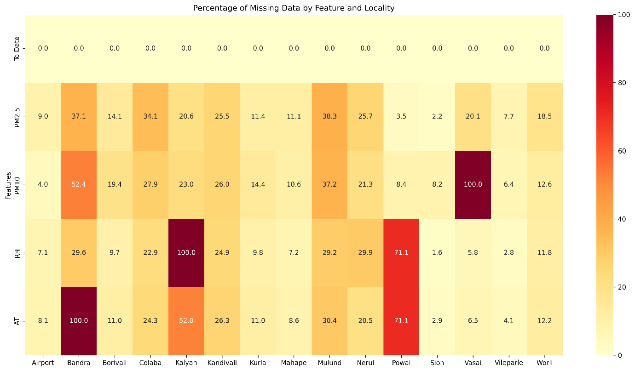
  - High-quality stations (>90% completeness): Sion (97.8%), Powai (96.5%), Vile Parle (92.3%), Airport (91.0%)
  - Moderate quality (75–90%): Kurla, Mahape, Borivali, Worli, Vasai, Kalyan
  - Low quality (<75%): Kandivali, Nerul, Colaba, Bandra, Mulund
- Missing Data Handling Techniques: (Cleaned data)
  - Linear interpolation (Most efficient)
  - Spatial averaging from neighboring stations (Best results)
  - Mean/median imputation
  - Fallback to localized temporal interpolation
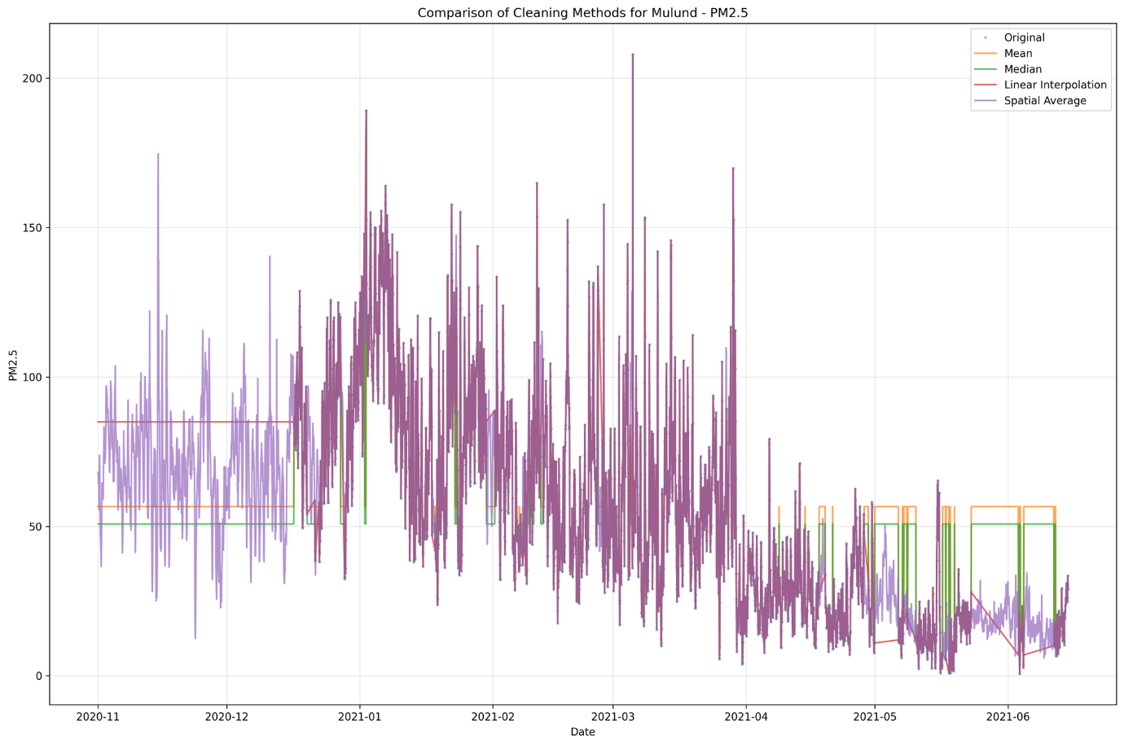
- Visual and statistical inspection confirmed spatial averaging and linear interpolation as most robust, particularly for high-missing-data stations like Bandra and Colaba.

2.1 Linear Regression: Implementation and Evaluation ref
Model: Standard LinearRegression (model = LinearRegression())
What Was Done
- Initial Approach:
  - Linear Regression was selected as a baseline model due to its simplicity and interpretability.
  - Cleaned datasets (via interpolation, spatial average, or statistical methods) were passed into the model per locality.
- Data Preparation:
  - Input features: hour, day, month, temperature, relative humidity, PM10, etc.
  - Training and testing split: 80/20 per locality.
- Cleaning Methods Compared:
  - Mean/Median Imputation
  - Linear Interpolation
  - Spatial Average (data from nearby stations)
- Feature Selection:
  - Used all available continuous variables.
  - No interactions or polynomial features were considered.

Why It Was Done
- Benchmarking:
To establish a simple, interpretable baseline for comparison with more complex models like Gradient Boosting and LSTM.
- Evaluation of Cleaning Methods:
Linear regression's sensitivity to missing values allowed us to evaluate how each cleaning strategy impacted performance.

Results
Cleaning Method | MAE | RMSE | MSE
Mean/Median | ~25 | ~30 | ~900
Linear Interpolation | ~20 | ~25 | ~625
Spatial Averaging | 18–20 | 22–25 | 484–625
- RMSE and MSE values were not consistent across all localities.
- Prediction Drift: Errors grew with prediction horizon.
- Boxplots: Showed better spread and stability for interpolation and spatial averaging methods.
- Loaded the model, found a date with complete data and performed prediction for it. Example, more results at ref:
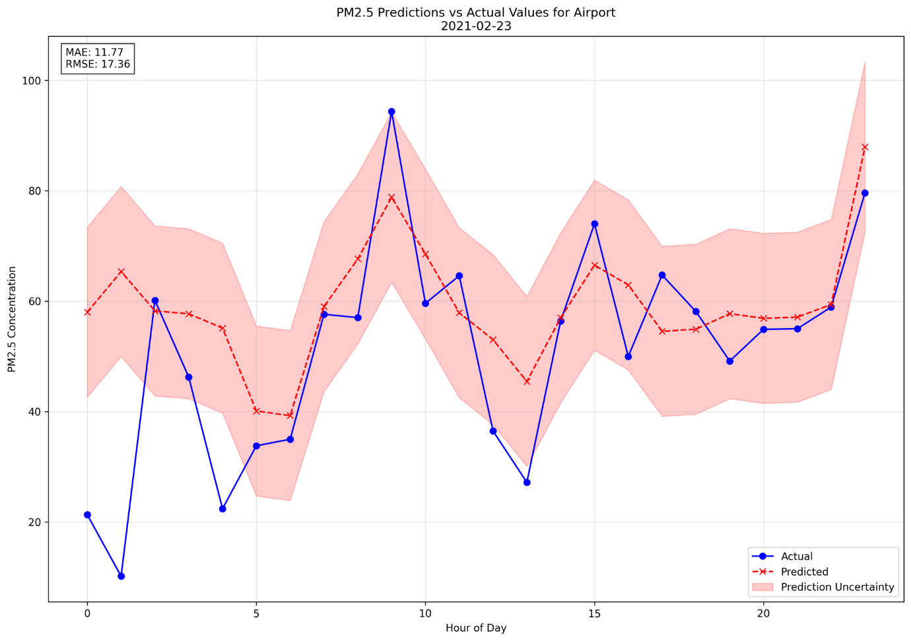

Challenges
- Weak Predictive Power:
Linear regression assumes a linear relationship between features and target. PM2.5 levels showed complex non-linear patterns (e.g., temperature inversely affects PM2.5 only in certain seasons).
- Overfitting on Sparse Data:
In localities with poor data quality (e.g., Bandra, Mulund), the model either overfit or underperformed drastically.

Conclusion
Linear regression helped identify strong baseline feature relationships and validated data cleaning strategies. However, it failed to capture the temporal and spatial dynamics essential for accurate PM2.5 forecasting. These limitations directly motivated the transition to non-linear models like Gradient Boosting and eventually LSTM, which significantly outperformed linear regression.

2.2 Gradient Boosting: Implementation and Evaluation
What Was Done
- Training Configuration:
  - Number of Trees: 200
  - Max Depth: 8
  - Learning Rate: default (0.1)
  - Objective: Regression (RMSE)
- Initial Dataset:
  - Cleaned data using linear interpolation
- Optimization Strategies:
  - Memory Constraints forced multiple changes:
    - Chunked CSV loading (1,000 rows per chunk)
    - Reduced features: used only essential ones (e.g., hour_sin, rolling_mean_6h)
    - Sequential horizon prediction (vs parallel)
    - Training per locality instead of combined model
    - Split data into 4 chunks with cooldown intervals to avoid overheating
    - Used incremental training and memory cleanup between chunks

Why It Was Done
- Motivation:
To build a stronger non-linear model capable of handling complex interactions that linear regression could not capture.
- Resource Considerations:
XGBoost was a logical next step before trying deep learning, but its ensemble-based architecture introduced scaling issues.
- Inter-feature Correlations:
PM2.5 is affected by multiple variables (e.g., PM10, temperature, humidity) in a non-linear way. XGBoost was ideal to explore this.

Results
Locality | MAE | RMSE | MSE
Airport | ~43 | ~50 | ~2500
Colaba | ~47 | ~57 | ~3250
Mulund | ~44 | ~55 | ~3025
- Average MAE: 45
- Average RMSE: 55
- Performance Drift: Accuracy dropped as prediction horizon extended.
- Example, more results at ref:
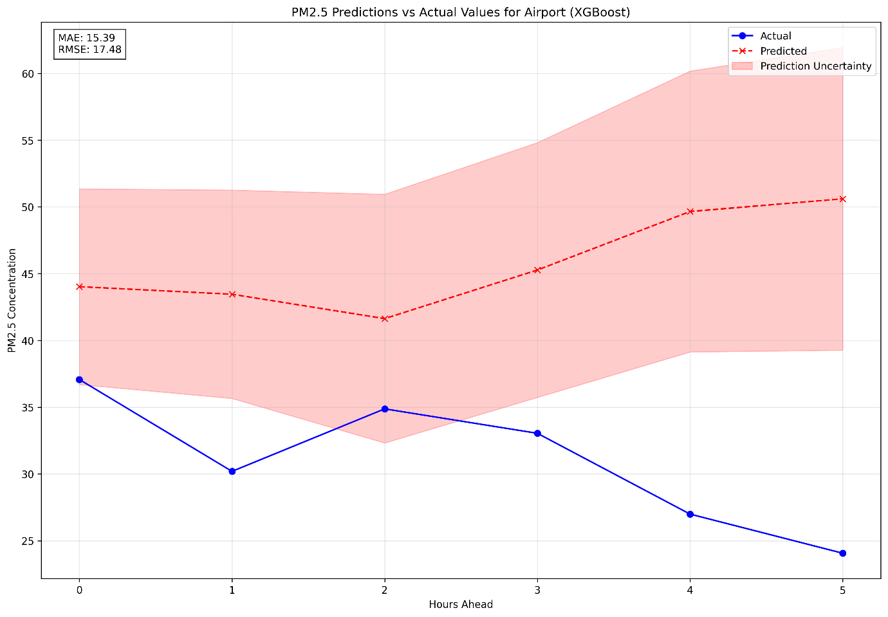
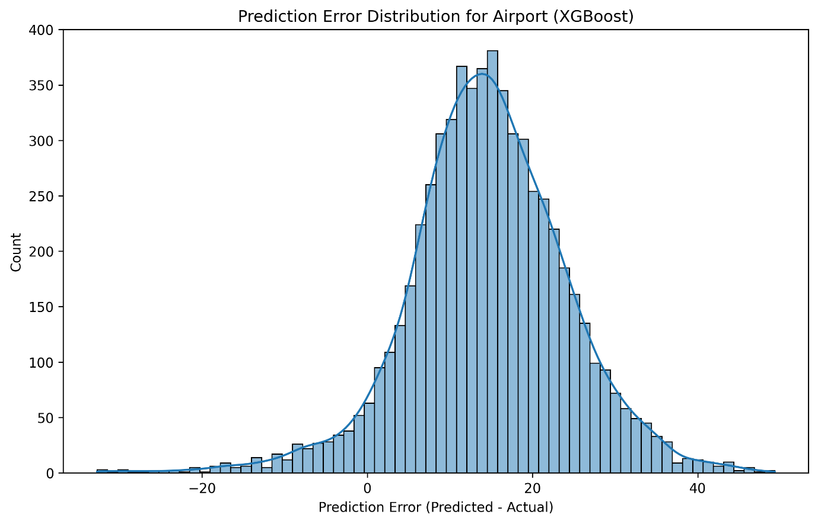

Challenges
- High Memory Usage:
Training across all localities or long sequences caused system crashes or slowdowns.
- Reduced Feature Set:
To reduce memory footprint, had to remove many useful features, hurting performance.
- Not Scalable:
Despite optimizations, performance gains plateaued and memory issues persisted, even after aggressive simplifications.

Conclusion
While Gradient Boosting outperformed linear regression in capturing non-linearity, it could not scale effectively with the full dataset or high feature richness due to resource limitations. The tradeoff between model accuracy and system feasibility led to the decision to adopt LSTM, which was more efficient for time series modeling and spatial integration.

2.3 Basic LSTM: Initial Implementation and Evaluation ref
What Was Done
- Model Architecture:
  - Single-layer unidirectional LSTM with:
    - 64 units
    - Dense output layer (1 neuron)
  - Used constant learning rate, no spatial data at this stage
- Input Configuration:
  - Input features per time step:
    - PM10, temperature, relative humidity, hour_sin, hour_cos, and rolling statistics
- Training Setup:
  - Epochs: 50
  - Batch size: 16
  - Train/Test Split: 70/30
  - Optimizer: Adam
  - Loss: MSE
- Memory Optimization:
  - Enabled GPU memory growth control
  - Cleared TF sessions after training
  - Used smaller sequences (24→12 hrs tested)
  - Avoided memory spikes by reducing batch size

Why It Was Done
- Overcoming Prior Limitations:
Linear regression lacked non-linearity; XGBoost had memory issues. LSTM was seen as a middle ground—offering better sequence modeling with acceptable resource usage.
- No Spatial Data Yet:
The first LSTM trial focused purely on temporal sequences to benchmark performance before adding geospatial complexity.

Results
Locality | MAE | RMSE | Notes
Airport | ~20 | ~23 | Better than XGBoost
Colaba | ~18 | ~22 | More stable predictions
Mulund | ~22 | ~25 | Prediction drifts further out
- Average MAE: ~20
- Average RMSE: ~23
- Prediction Drift:
Performance degrades when predicting further into the future.
- Example, more results at ref:
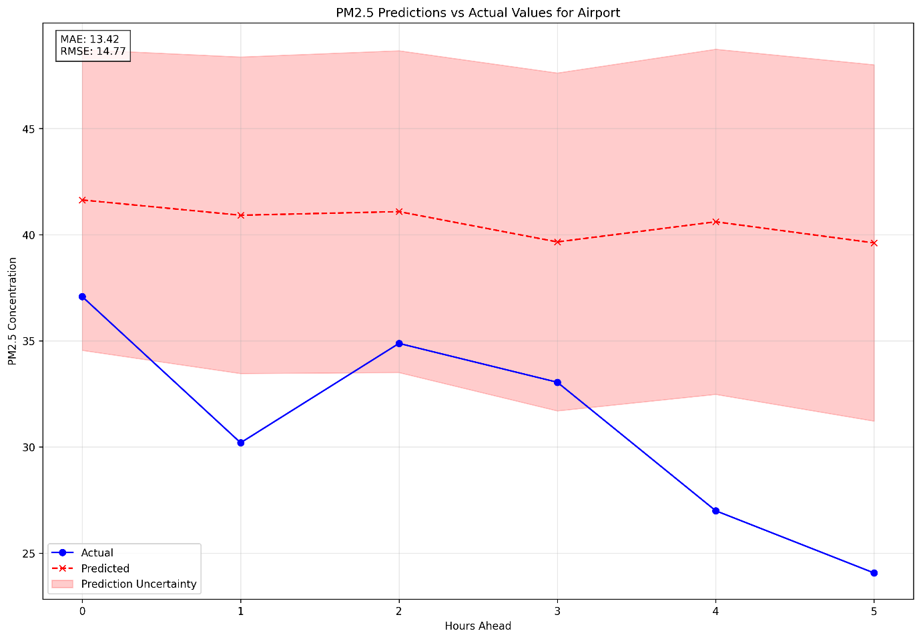
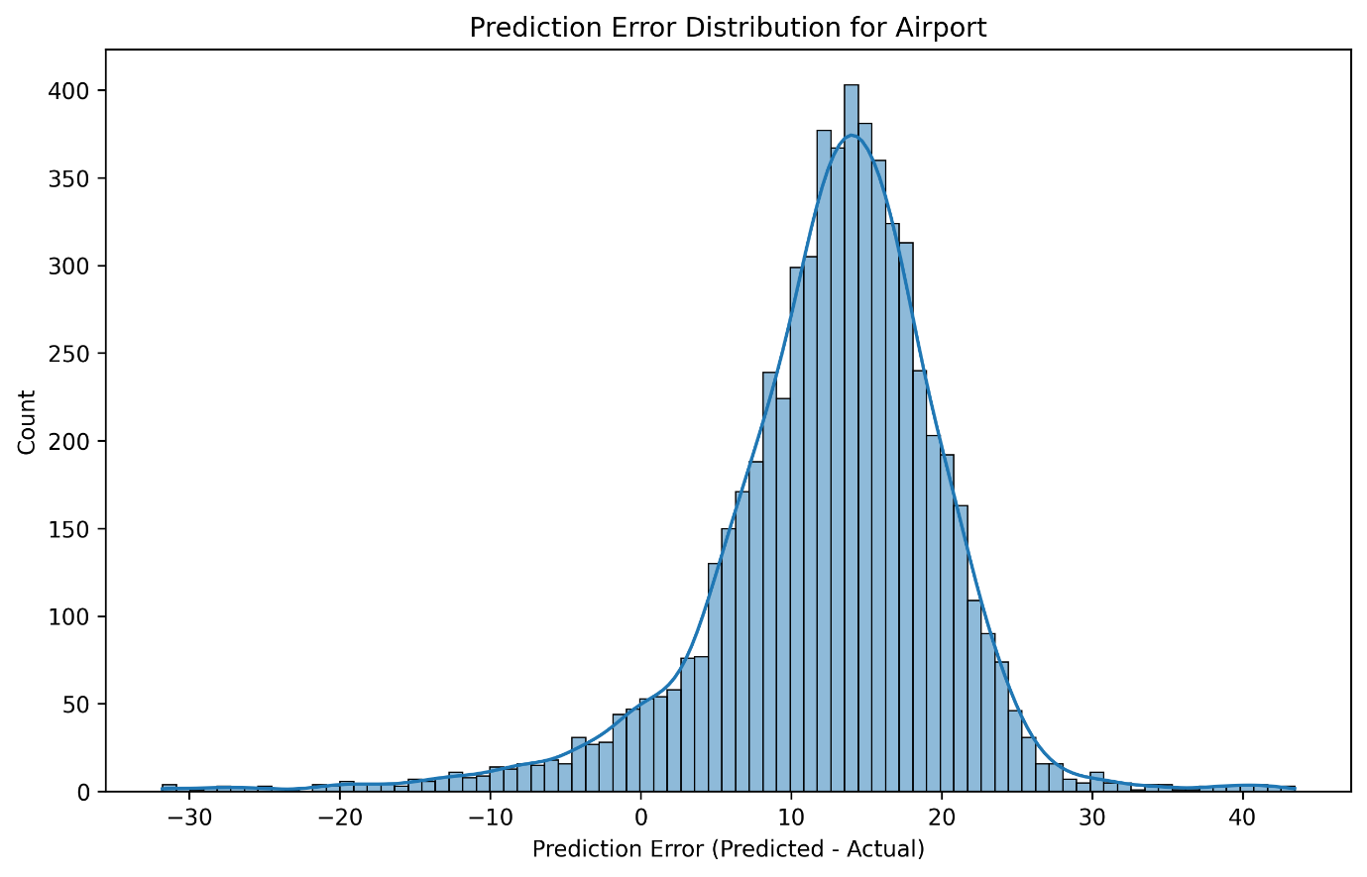

Challenges
- Temporal Instability:
Without spatial feedback, predictions were sensitive to outliers or data gaps.
- Simplified Architecture:
A single-layer model limited the depth of temporal pattern learning.
- Resource Limits:
Still required tuning to fit on GPU; long sequences and large batches caused instability.

Conclusion
The basic LSTM significantly outperformed both linear regression and XGBoost, validating its suitability for this forecasting task. However, the model lacked spatial awareness and had room for architectural and regularization improvements. This trial set the foundation for a more advanced LSTM model in the next stage.

2.4 LSTM Model Improvements for PM2.5 Prediction
Overview
1. Enhanced Feature Engineering
Implemented Changes:
- Fetched location coordinates and used nearby localities to fill missing data:
  - Used OpenStreetMap to fetch coordinates for all localities (Spatial cleaned data)
  - Only considered localities within 10km as nearby localities and used their weighted data to fill missing data ref
- Expanded Temporal Features:
  - Added day of week and weekend indicator features
  - Created sin/cos transformations for cyclical variables to better capture periodicity. It captures hour 23 is close to hour 0 and December is close to January ref
- Advanced Statistical Features:
  - Added rolling window statistics to capture short term trends (6 hour avg), medium trends (12 hr) and daily trends (24 hr avg)
  - Added 12-hour min/max values
  - Implemented long-term lag features (12h and 24h) to capture trends in PM2.5 values
  - Added more rate-of-change features (6h and 12h) ) to capture trends in PM2.5 values
- Improved Data Preprocessing:
  - Implemented log transformation for the target variable (PM2.5)
  - Applied robust scaling for features to handle outliers better
Rationale:
The original model was likely overfitting due to too many redundant features. By focusing on more meaningful features and improving normalization techniques, the model could better generalize to unseen data. The log transformation helped normalize the skewed PM2.5 distribution, while robust scaling reduced the impact of outliers.
2. Final LSTM Architecture
- Layers:
  - Input → Bi-LSTM (64) → Dropout(0.3) → Residual Bi-LSTM (64)
  - Dense(128) → BatchNorm → Dense(1)
- Regularization:
  - Dropout + recurrent dropout
  - L2 regularization
- Training:
  - Epochs: 150
  - Batch size: 64
  - Early stopping patience: 20
  - Learning rate: warm-up + ReduceLROnPlateau (decay 0.95 every 500 steps)
- Performance Optimization:
  - Spatial data missing data handling for better data quality, log transformation of PM2.5
  - RobustScaler for outlier handling
Rationale:
The advanced architecture with residual connections helps mitigate the vanishing gradient problem in deep networks. Batch normalization stabilizes and accelerates training, while recurrent dropout specifically regularizes the recurrent connections in LSTM cells, preventing overfitting.
3. Optimized Training Process
Implemented Changes:
- Dynamic Learning Rate Adjustment:
  - Added ReduceLROnPlateau callback to dynamically adjust learning rate during training
  - Fine-tuned learning rate decay (faster decay rate of 0.95 every 500 steps)
Rationale:
The warm-up phase helps avoid initial training instability, while gradual decay helps fine-tune weights as training progresses. Increased patience prevents premature stopping during temporary plateaus, allowing the model to find better minima.
Locality-Specific Results:
Locality | MAE | RMSE
Colaba | 1.99 | 4.08
Sion | 4.38 | 5.61
Powai | 5.88 | 8.30
Airport | 6.56 | 8.50
Borivali | 5.95 | 9.14
Worli | 5.73 | 8.47
Kurla | 10.40 | 23.73
Kalyan | 12.31 | 16.93
Bandra | 9.47 | 12.76
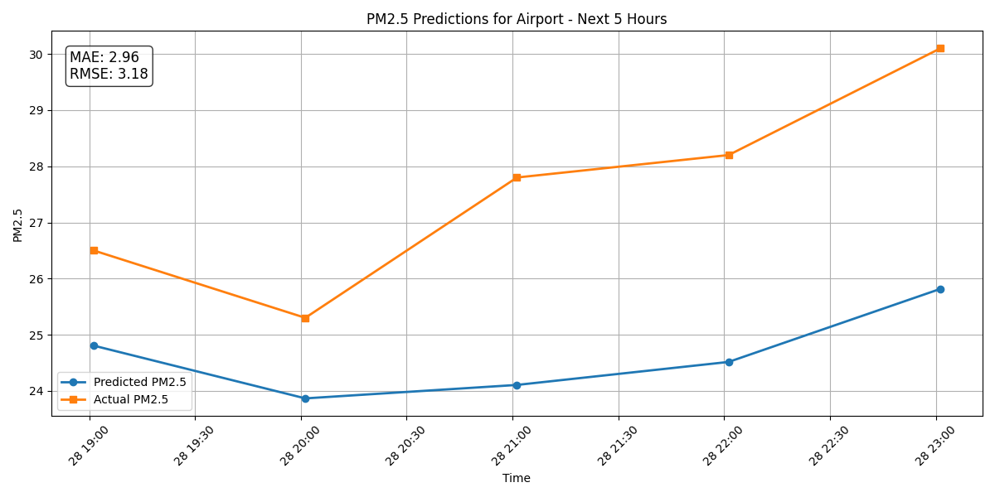
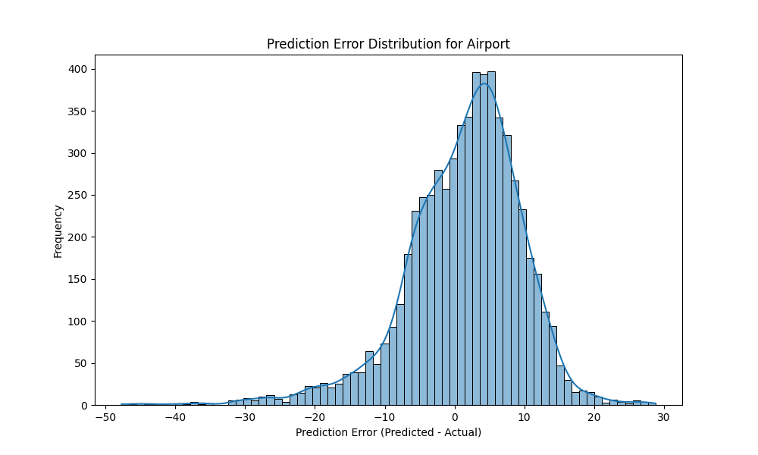
- Example, more results at ref:

Key Observations:
- Localities with more nearby neighbors (like Colaba, Sion, and Powai) achieved the best results
- Localities on the periphery (like Kalyan) showed higher error rates but still significant improvement
- The spatial approach was particularly effective for localities with many nearby neighbors
Conclusion
The combination of enhanced feature engineering, improved model architecture, optimized training process, and spatial data integration resulted in a dramatic improvement in PM2.5 prediction accuracy. The final model significantly outperformed the original implementation, with an 88% reduction in MAE.
These improvements demonstrate that a holistic approach to time series forecasting—combining proper data preprocessing, appropriate model architecture, and domain-specific features (like spatial relationships)—can dramatically improve LSTM performance for environmental monitoring applications.

3.1 Final Model Results
Model | Notes | MAE | RMSE
Linear Regression | Baseline model | ~20 | ~25
XGBoost | 200 trees, depth=8, chunked training | ~45 | ~55
Initial LSTM | 1 layer, 64 units, constant LR | ~20 | ~23
Final LSTM | Bidirectional, residuals, dropout, spatial | 4.84 | 7.36

4. Key Takeaways
- Linear models underperformed due to assumptions of linearity.
- XGBoost captured interactions but was not scalable for multi-station, long-horizon prediction.
- LSTM (with advanced architecture and spatial features) balanced performance and scalability.
- Feature richness and spatial reasoning were critical for outperforming baseline models.
- Resource-efficient LSTM optimization (reduced units, sequence length, memory cleanup) enabled model training on limited hardware.

